# Basic Digital Integrated Circuits (ICs)

Written by Mark Webster

Summary

In this workshop learn to build some basic circuits which are the building blocks of all computers and digital devices.

## Introduction

An analog circuit takes on a wide range of voltages. A digital circuit changes between two voltage levels, a high and low voltage, typically +5 and 0V, or +3.3V and 0V. Generally it is easier to make circuits that only use two voltage states.

<https://en.wikipedia.org/wiki/Digital_electronics>

## Truth Tables

<https://en.wikipedia.org/wiki/Truth_table>

Given two inputs which can be TRUE=1 or FALSE=0 (high=+5V or low=0V voltage in digital circuits) a truth table defines what the output of the circuit would be.

|  |  |  |  |  |  |
| --- | --- | --- | --- | --- | --- |
| P | Q | OR | AND | NOR | NAND |
| T | T | T | T | F | F |
| T | F | T | F | F | T |
| F | T | T | F | F | T |
| F | F | F | F | T | T |

## Logic Gates

<https://en.wikipedia.org/wiki/7400-series_integrated_circuits>

Logic gates are integrated circuits that implement the behavior of various truth table functions.

Logic gates have standard symbols on schematics.

<https://en.wikipedia.org/wiki/Logic_gate#Symbols>

### NAND, 7400 chip

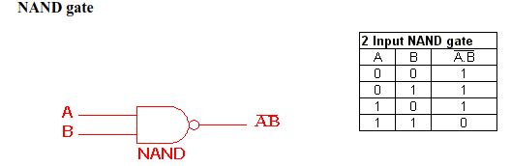(replace)

#### Example 1: NAND gate test circuit

***Hardware:*** Breadboard, 4011 quad Nand chip (only the gate on pins 1,2,3 will be used. 10 k ohm resistor, 370 ohm resistor, LED, two push buttons, +5V power supply, various wires.

***Software:*** None.

Press the push buttons one at a time and verify the NAND truth table. +5 means the button is pressed.

|  |  |  |
| --- | --- | --- |
| Pin 1 | Pin 2 | NAND output (LED on or off) |
| 0 | 0 |  |
| 0 | +5 |  |
| +5 | 0 |  |
| +5 | +5 |  |

.

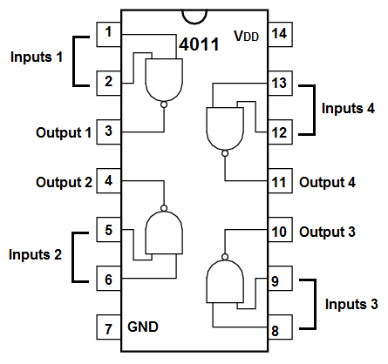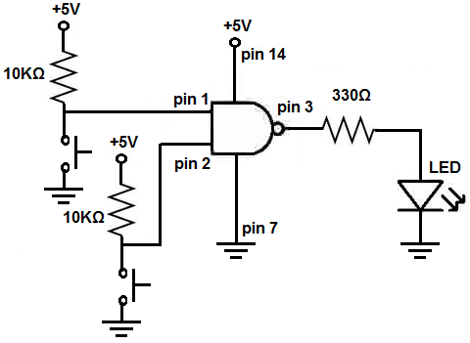  
(Replace)

### NOR, 7402 chip

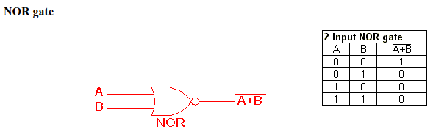(replace)

## Decade Counter

<https://en.wikipedia.org/wiki/Counter_(digital)>

Digital counter circuits can count in binary or decimal.

Counter circuits can count up or down.

They can be used as divide by 10 and divide by 5 counters.

The 4017 is a simple decade counter that increments from 0 to 9, then starts over again at 0, but with a carry pin. Each clock pulse increments the count.

Decade counters can be used to sequentially light up a string of LEDs in a circle or string. Or do a sequential tasks, like swing open a door, then stop opening at a certain point. Decade counters can also work as a divide by 10 or divide by 5 circuit such as to convert 60 hz into 6 hz.

### BCD (Binary Coded Decimal)

The numbers 0 to 9 can be encoded in binary. A BCD decade counter will count pulses and send outputs as a four digit binary number. When the number of pulses reaches 10, the count starts over.

A regular decade counter (also called a divide by 10 divider) will just sequentially set 1 out of 10 pins high.

#### Exercise 2: Decade Counter with LED

***Hardware***: breadboard, LED bar, 4017 decade counter, 10x 470 ohm resistors, push button, lots of wires, +5 v power supply

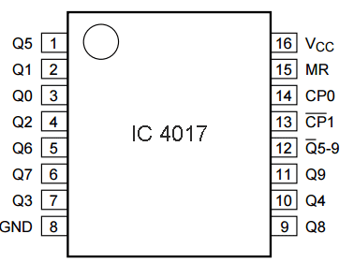

|  |  |  |
| --- | --- | --- |
| **PIN NO.** | **PIN Name** | **PIN Description** |
| 1 | Q5 | Output 5: Goes high in 5 clock pulse |
| 2 | Q1 | Output 1: Goes high in 1 clock pulse |
| 3 | Q0 | Output 0: Goes high at the beginning – 0 clock pulse |
| 4 | Q2 | Output 2: Goes high in 2 clock pulse |
| 5 | Q6 | Output 6: Goes high in 6 clock pulse |
| 6 | Q7 | Output 7: Goes high in 7clock pulse |
| 7 | Q3 | Output 3: Goes high in 3 clock pulse |
| 8 | GND | Ground PIN |
| 9 | Q8 | Output 8: Goes high in 8 clock pulse |
| 10 | Q4 | Output 4: Goes high in 4 clock pulse |
| 11 | Q9 | Output 9: Goes high in 9 clock pulse |
| 12 | CO –Carry out | Used to cascade another 4017 IC to makes it count upto 20, it is divide by 10 output PIN |
| 13 | CLOCK inhibit | Clock enable pin, should kept LOW, keeping HIGH will freeze the output. |
| 14 | CLOCK | Clock input, for sequentially HIGH the output pins from PIN 3 TO PIN 11 |
| 15 | RESET | Active high pin, should be LOW for normal operation, setting HIGH will reset the IC (only Pin 3 remain HIGH) |
| 16 | VDD | Power supply PIN (5-12v) |

Make a decade counter with at least 4 LED pins. Use a push button as a manual clock signal.

Pin numbers begin at the end of the chip with the indented circle.

Pins 13 and 15 must be held low. The low side of the push button goes to the clock on pin 14. Pin 16 must be power from +5 to +12V. Pin 8 goes to ground. The other pins go to the LED bar. The count sequence unfortunately isn’t a sequential pin order but jumps around.

The LED bar must go through resistors, about 270 ohm, to ground.

Compared to analog circuits, digital circuits tend to have lots of wires, and lots of similar components. A PCB board is highly desired with digital circuits.

Notice how hard it it to press the push button quickly enough to only step one LED and not skip counts. This is because buttons have bounce (multiple pulses while the contacts are closing). Software or hardware debounce is needed for real world applications using buttons.

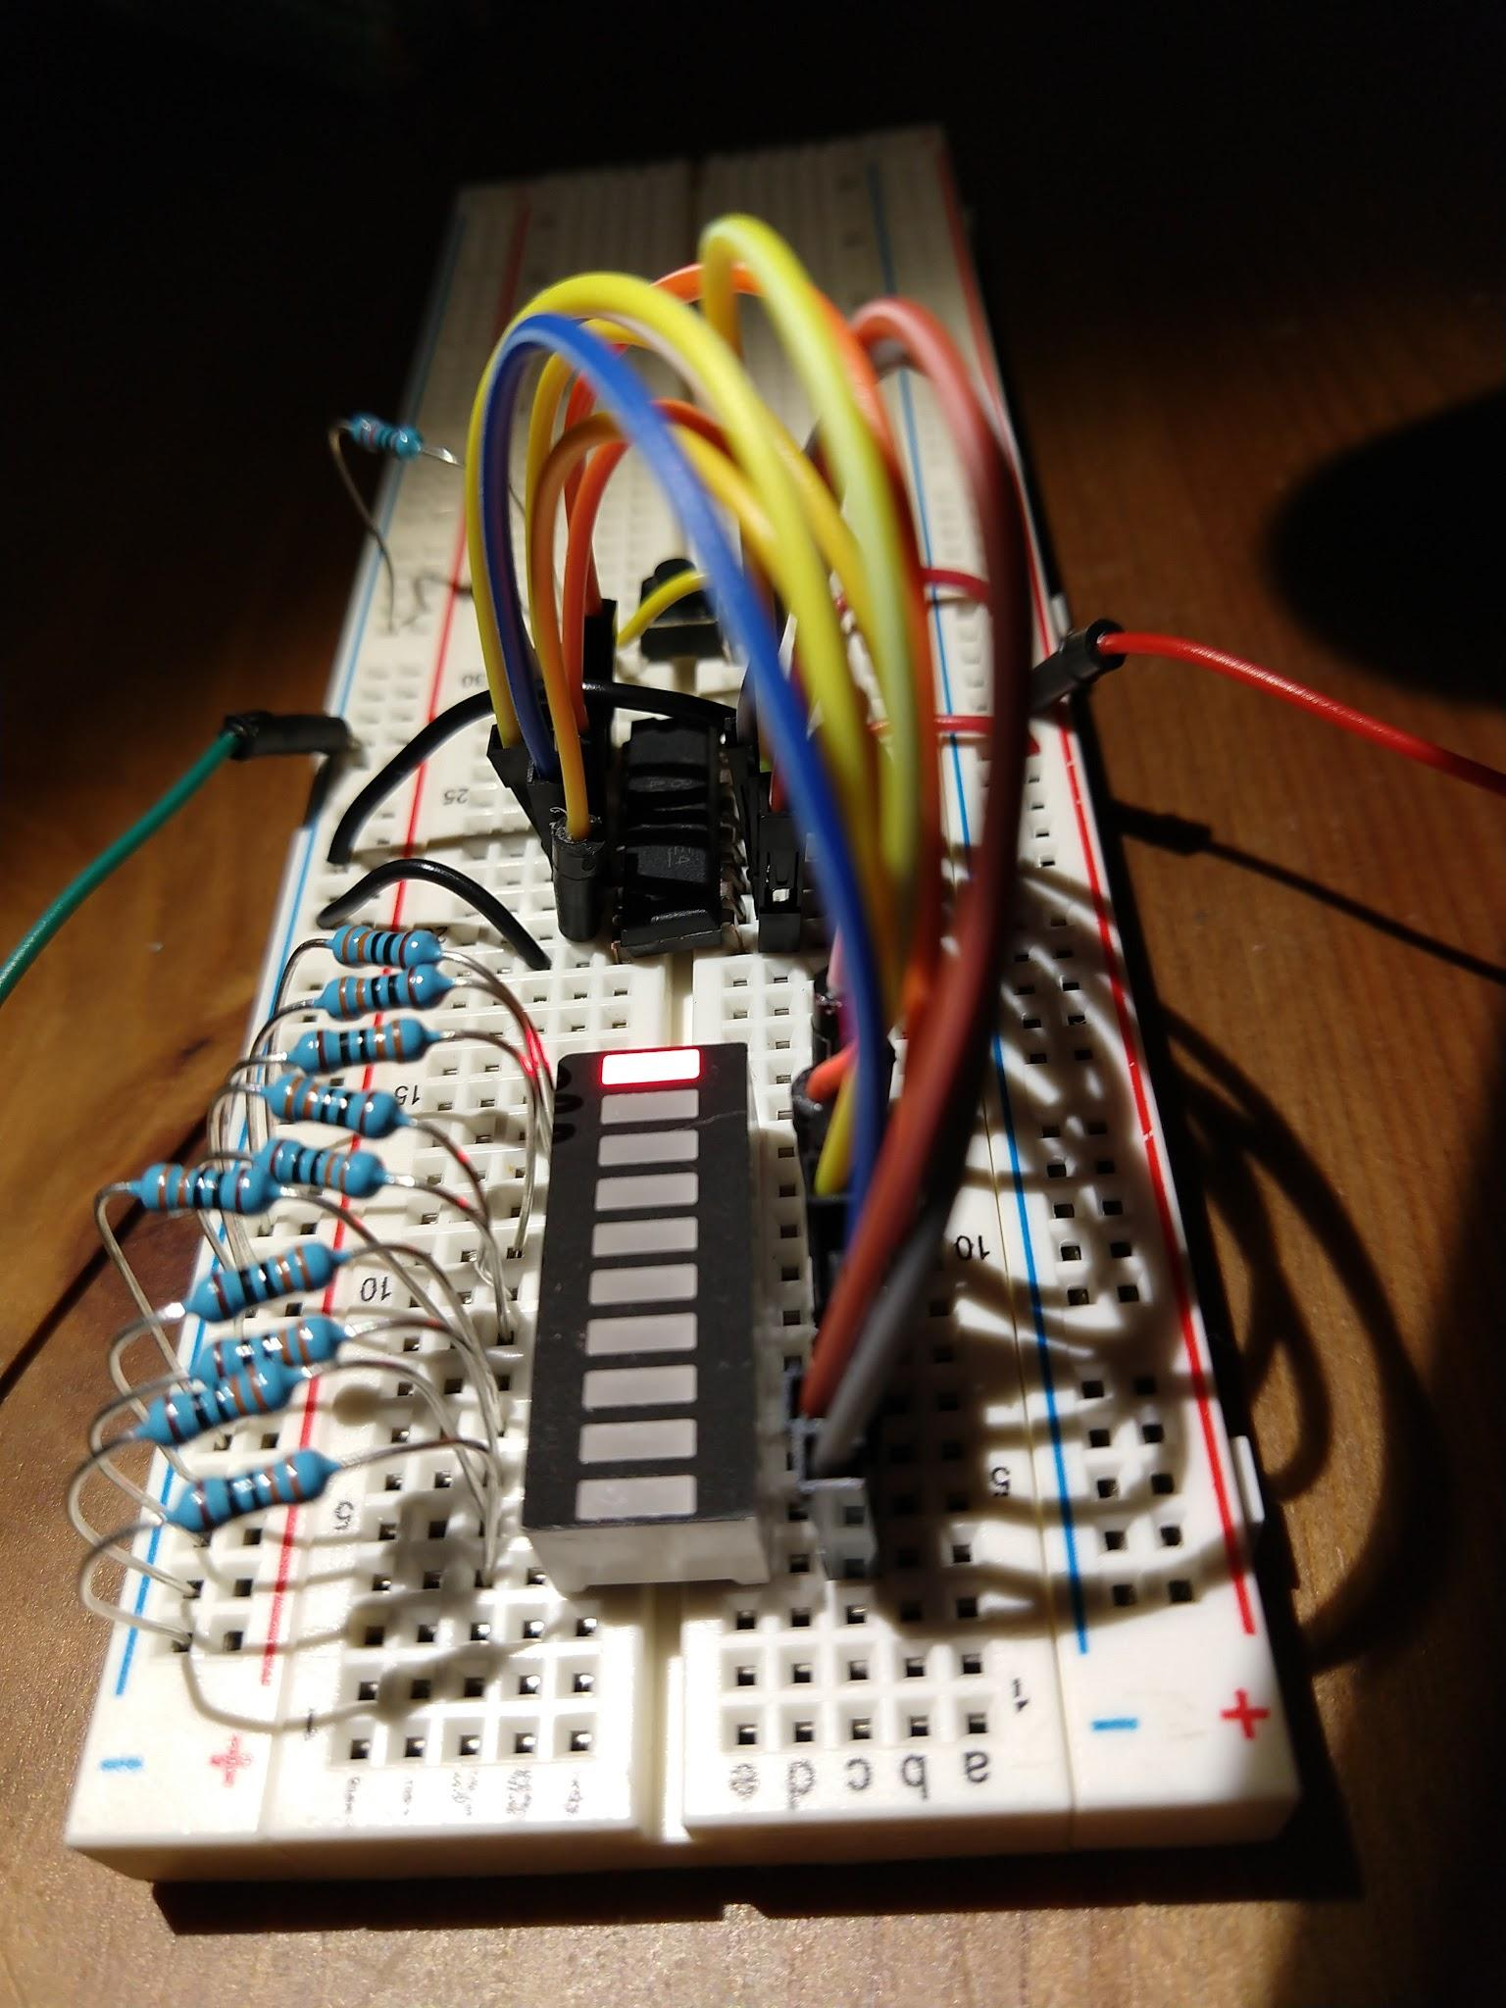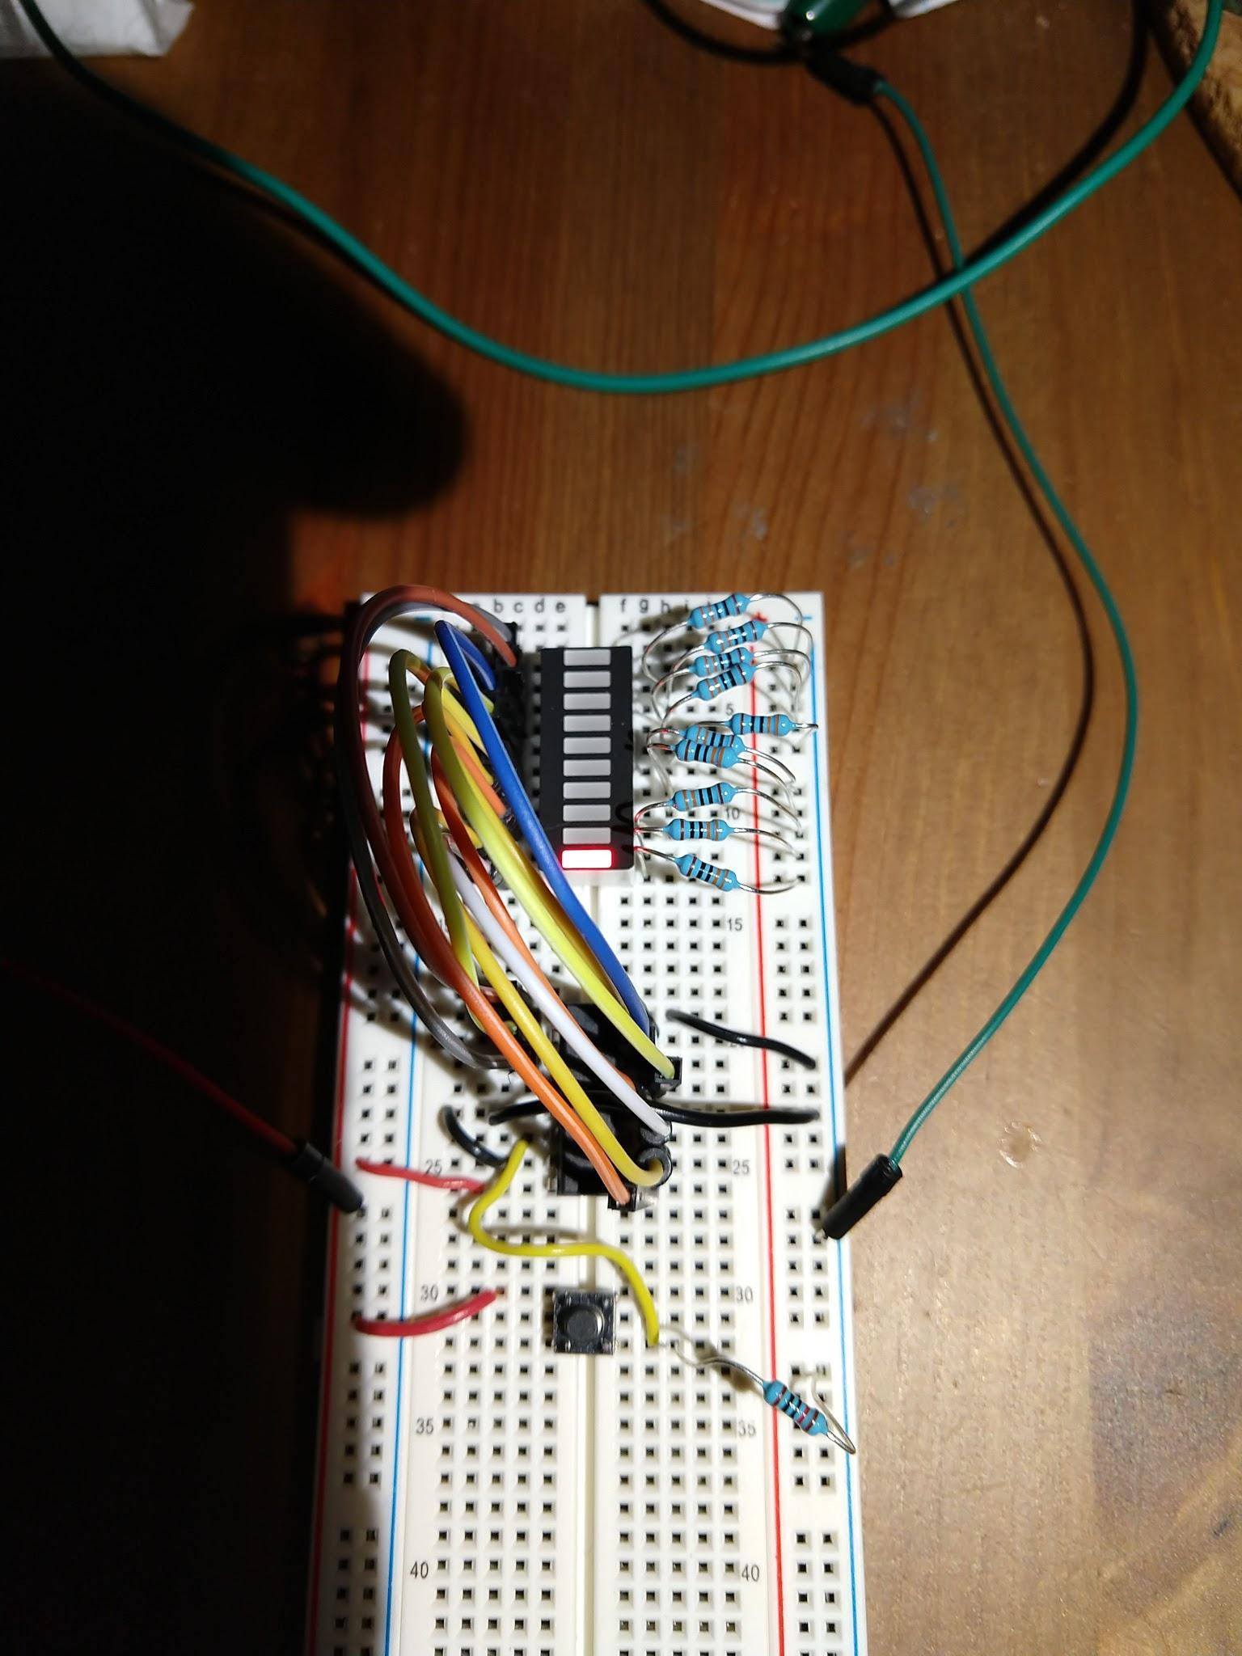

The decade counter with a push button illustrates the problem of button bounce.

## Flip Flop (Latch)

<https://en.wikipedia.org/wiki/Flip-flop_(electronics)>

Two NAND gates are used to make a flip flop. Sometimes the flip flop is called a latch, since it switches between two states and stays there.

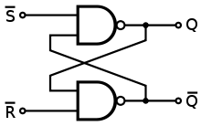

#### Exercise 3: Switch Debounce

***Hardware***: 4011 NAND chip, two pole switch, LED, 1x 470 ohm resistor for LED, 2x 1K resistors for 4011, breadboard, wires, +9V or +5V power supply

A flip-flop circuit can be used to ignore multiple pulses generated when a switch or relay closes. The flip-flop is made from two NAND gates. Most digital gate chips have four gates per chip, so there is only one IC chip.

Use a 4011 NAND chip, a two pole switch with two pins tied to +5 with 1K resistors, and an LED with limiting resistor on a breadboard. Pin 7 of the NAND chip is connected to ground and pin 14 is +5 V (Vcc or Vdd).

When the switch is one way, the LED lights up, when the switch is the other way, the LED is dark. There is no flickering due to switch contacts bouncing.



